# Admin view to edit product description and details

1. Log on wix.com – 2 people can log on as admin – [Srivastava.jeetesh@gmail.com](mailto:Srivastava.jeetesh@gmail.com), blissfulseeds@gmail.com.

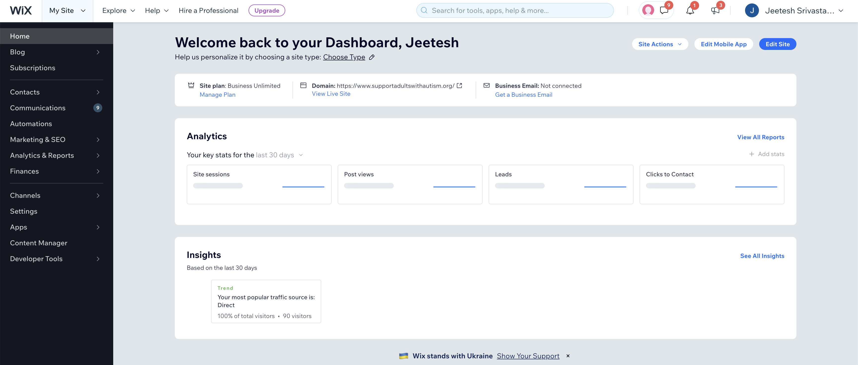

1. Select edit site , to open up edit dashboard page

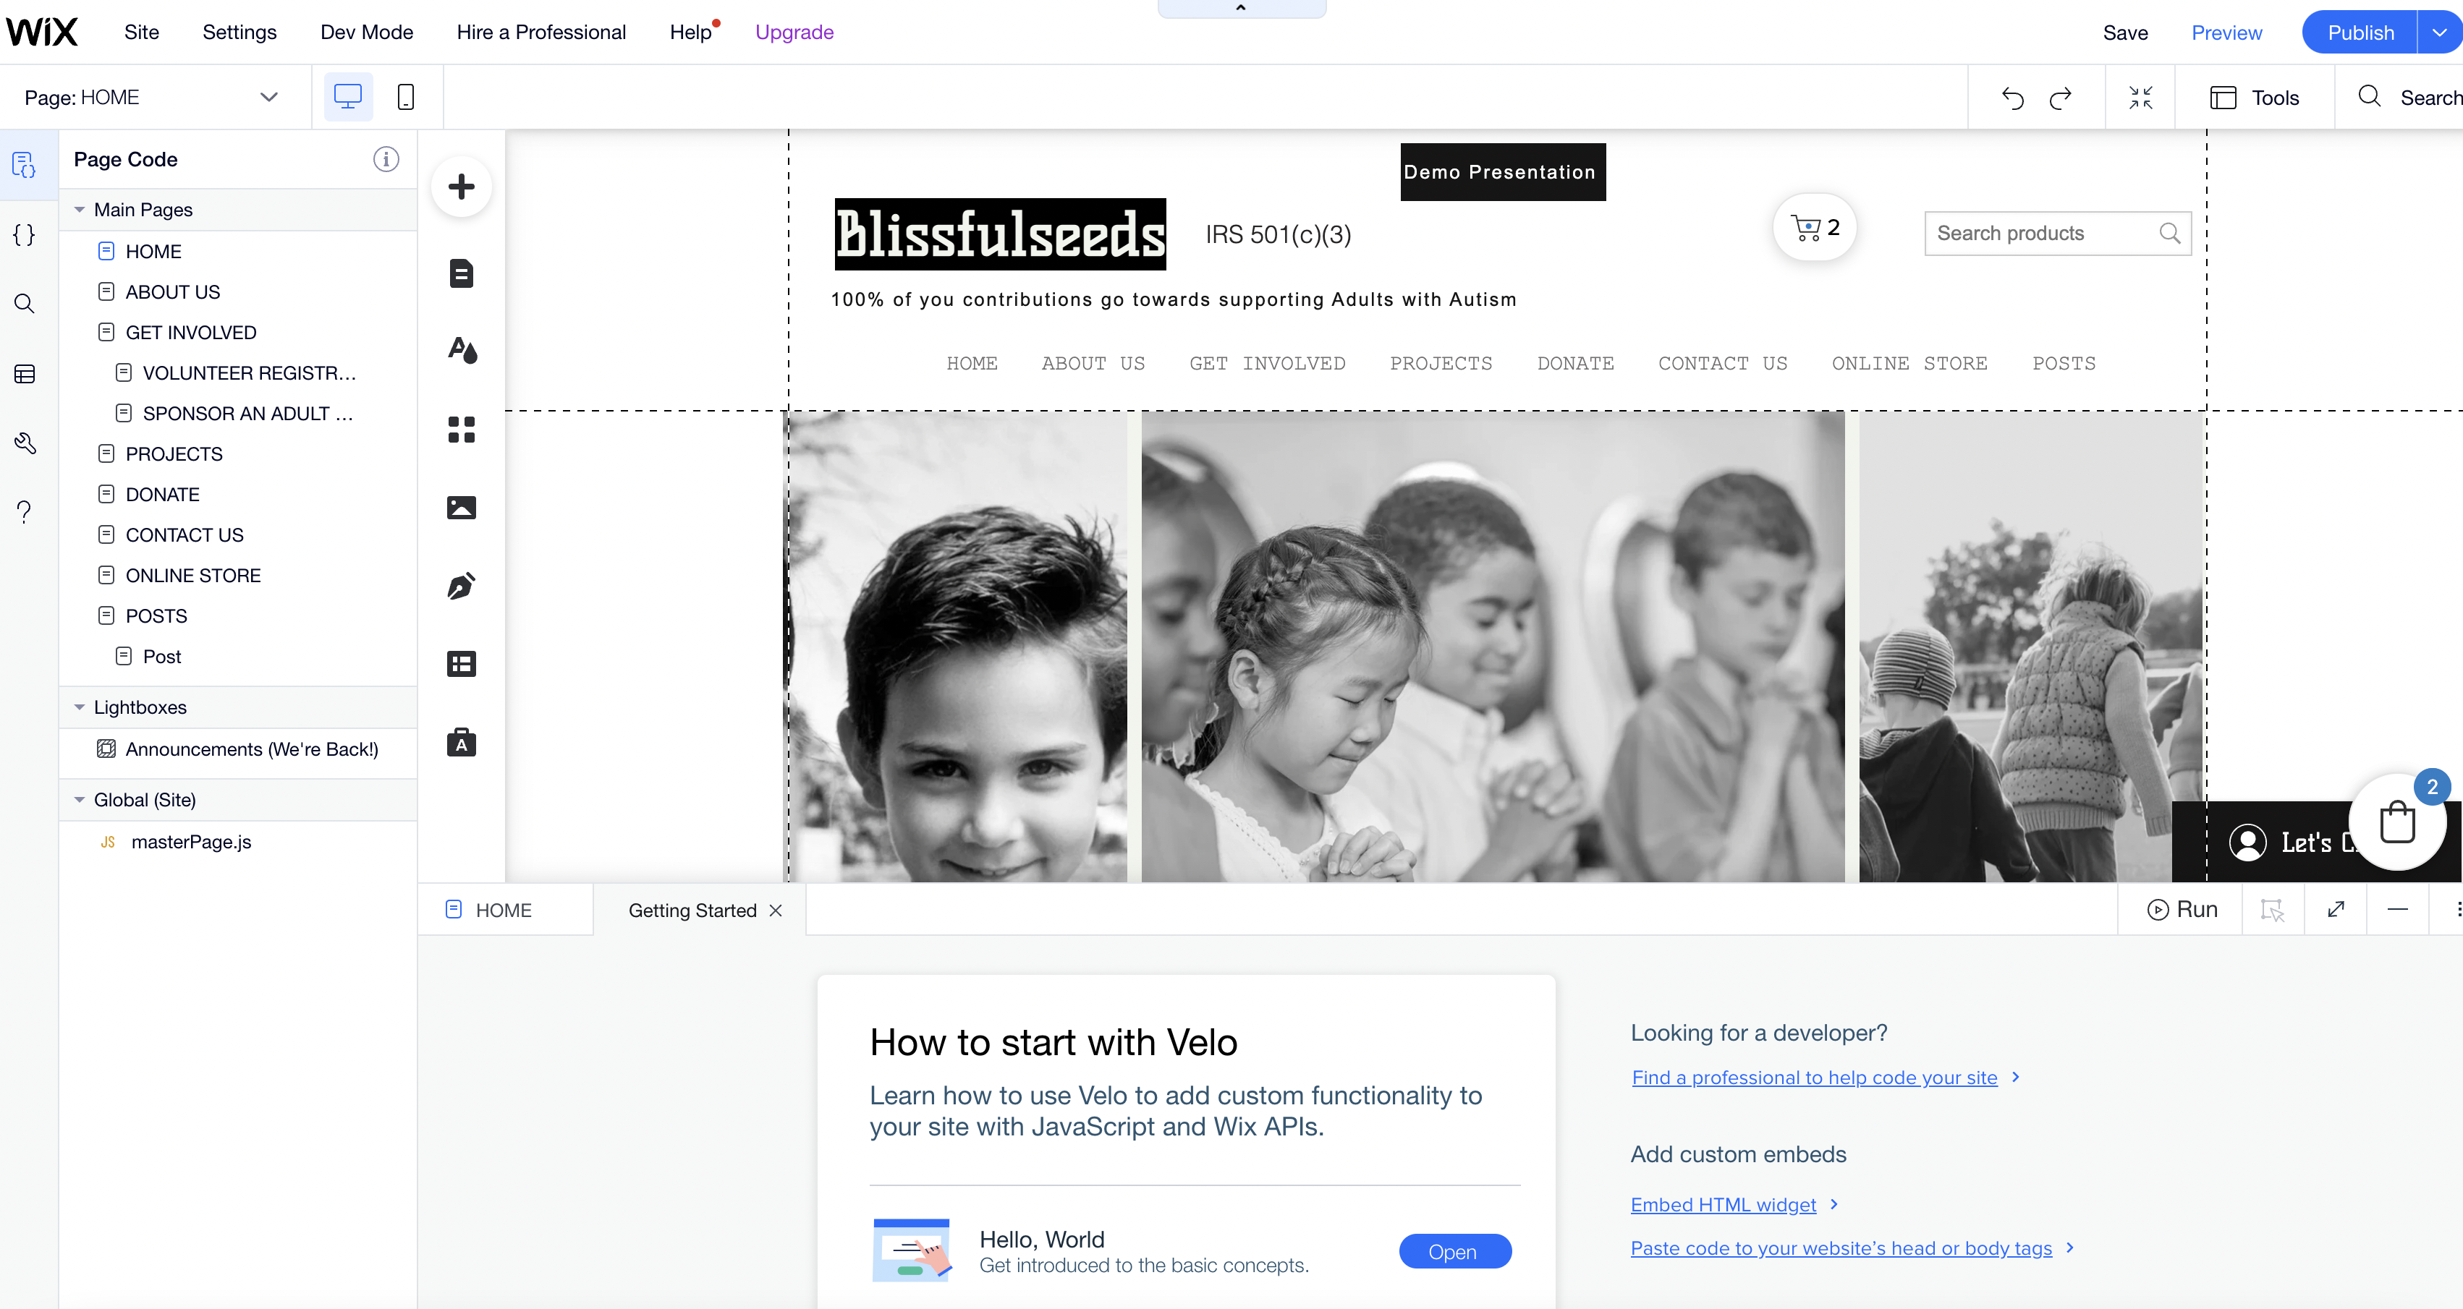

1. Select pages on the top left hand side, double click online store.

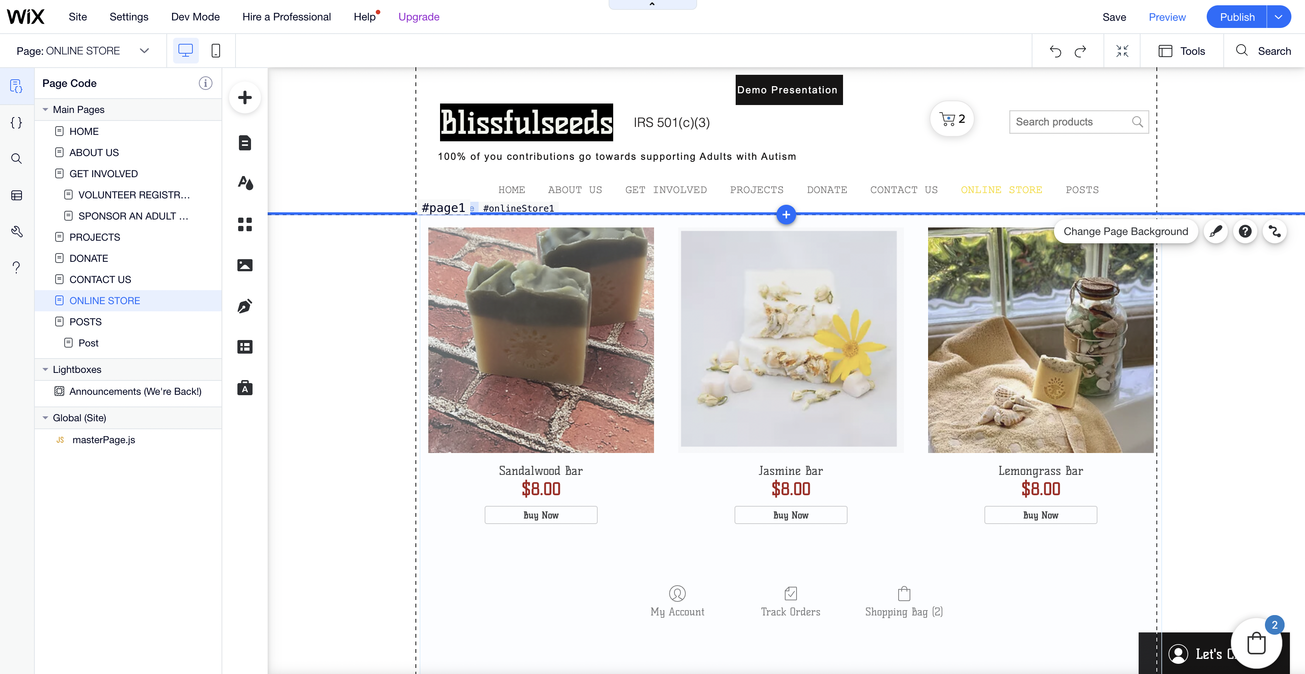

1. Click on an image and select settings

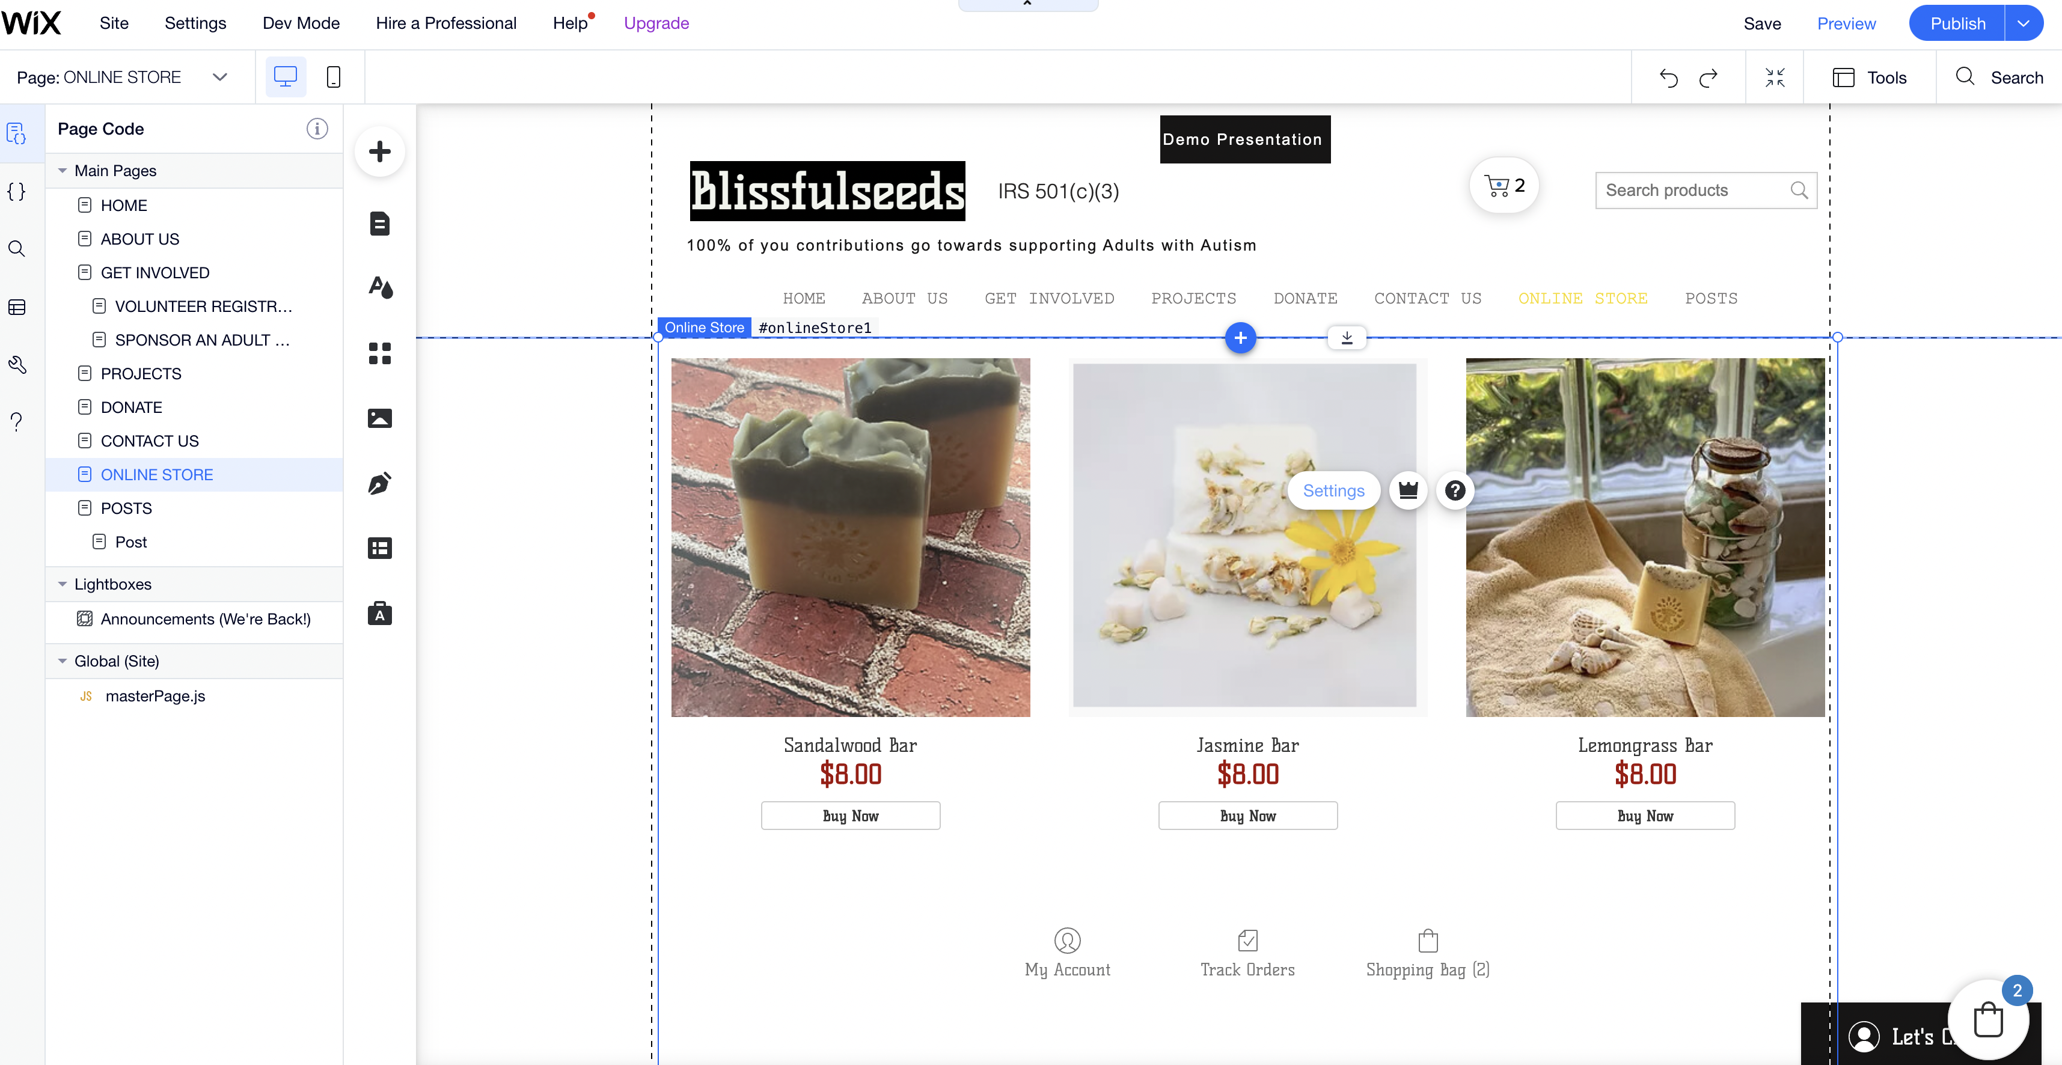

1. Select manage store

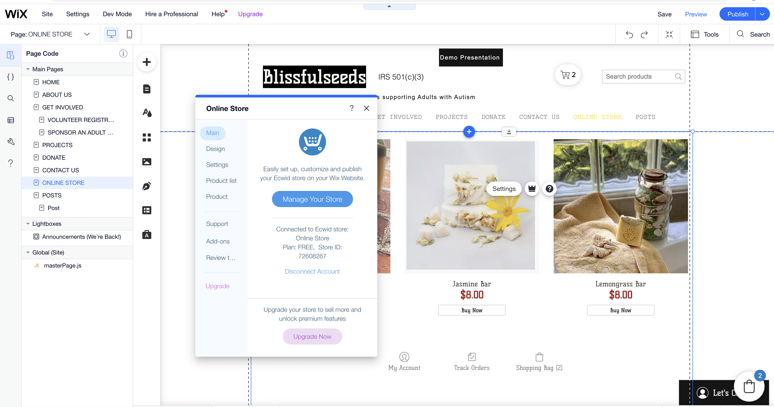

It should open up a webpage with store details

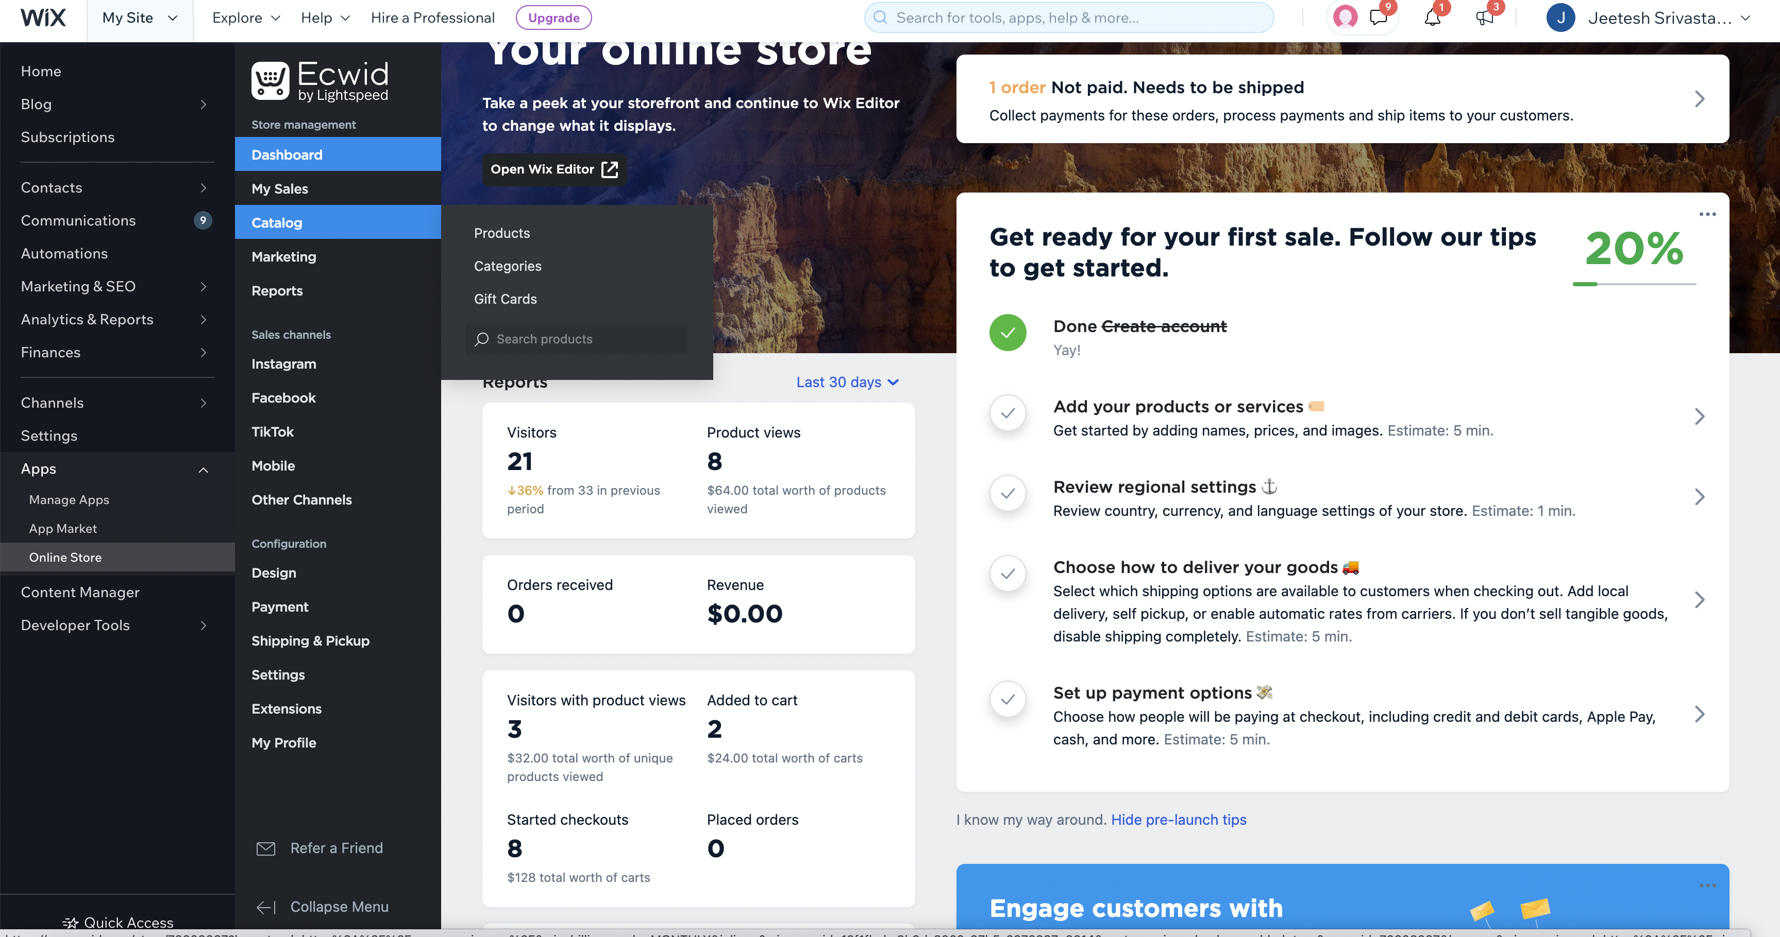

1. Browse to catalog and select products



1. Add or modify an existing product details

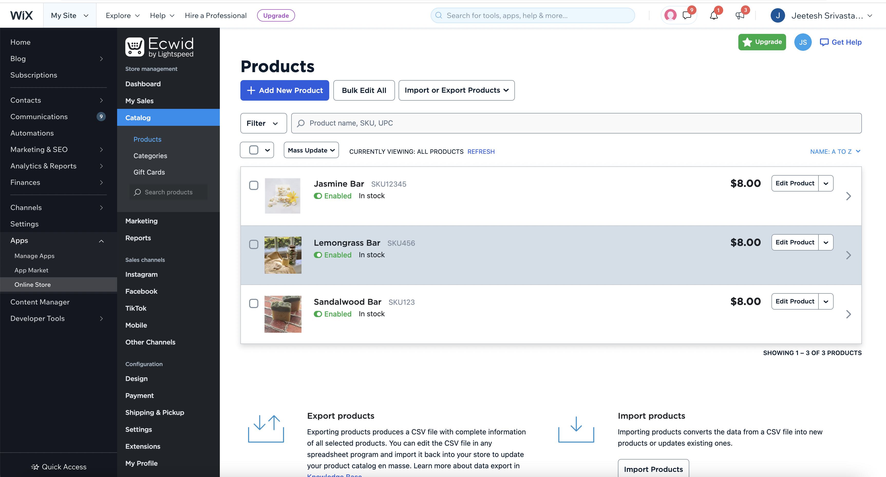

1. Finally, once changes are made ,select publish to deploy the site

